**Normal Distribution**

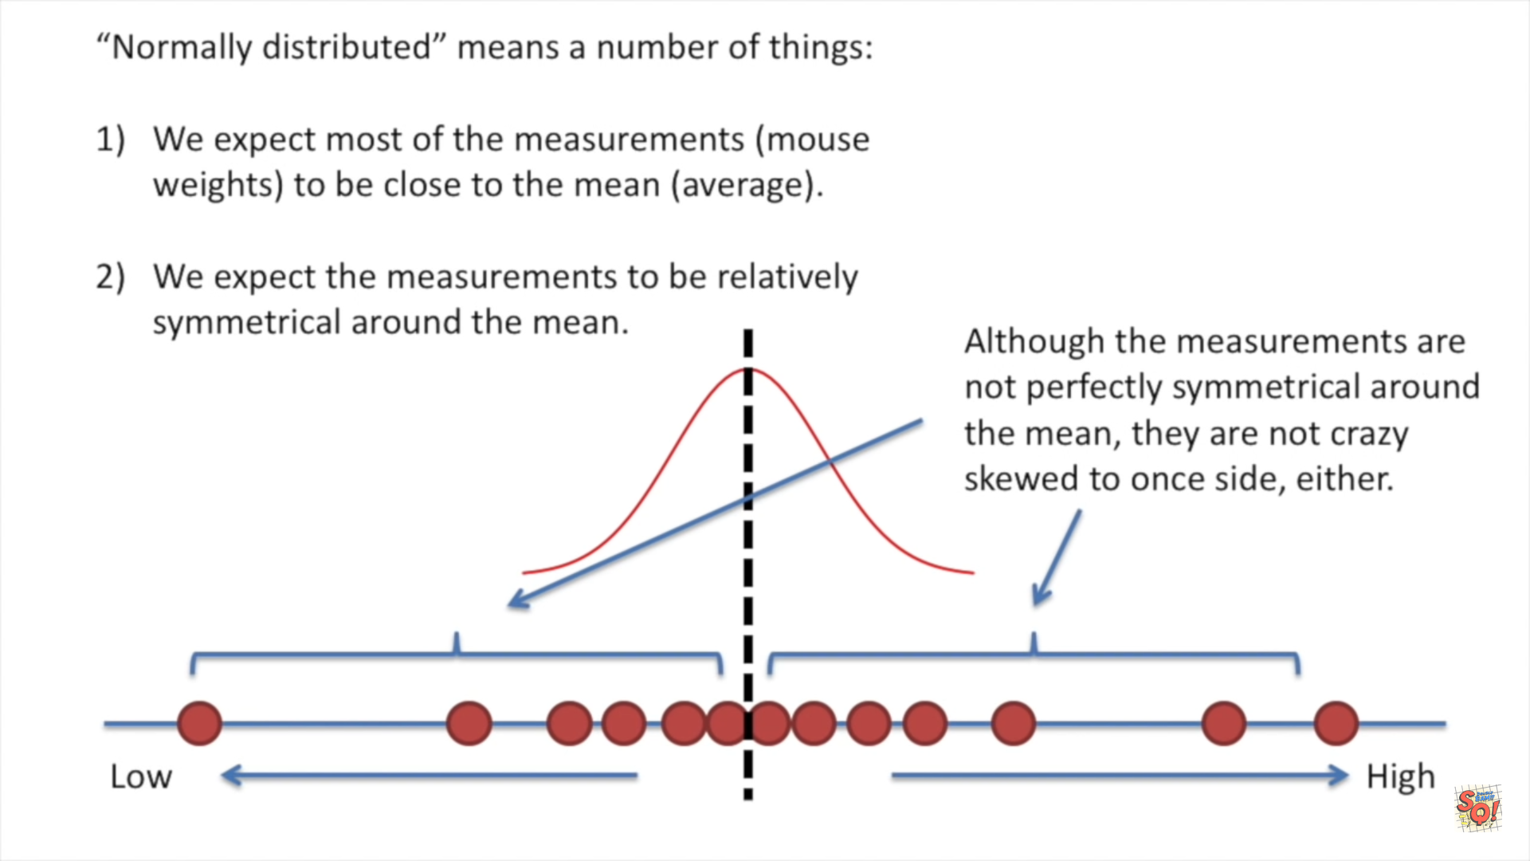

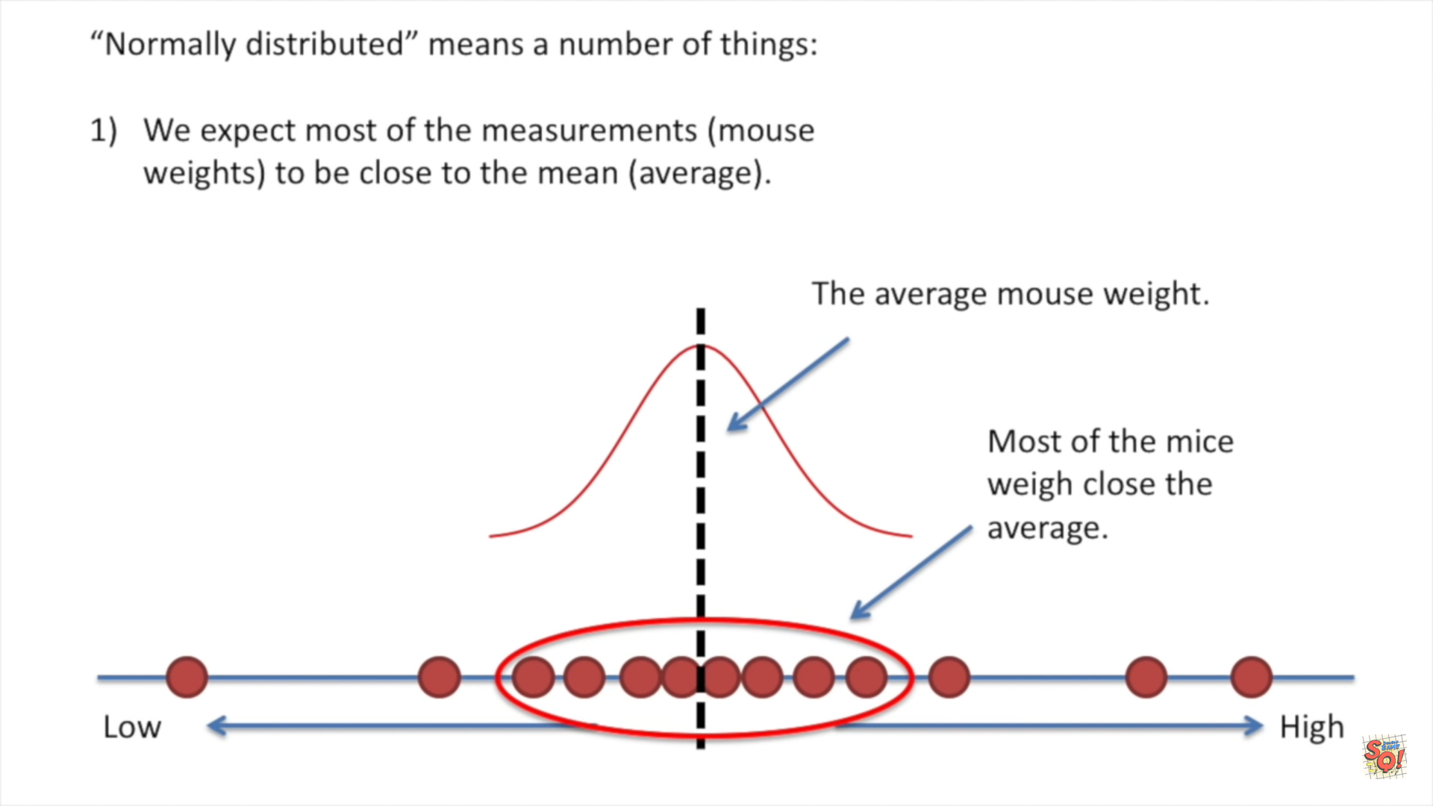

**Case-1**

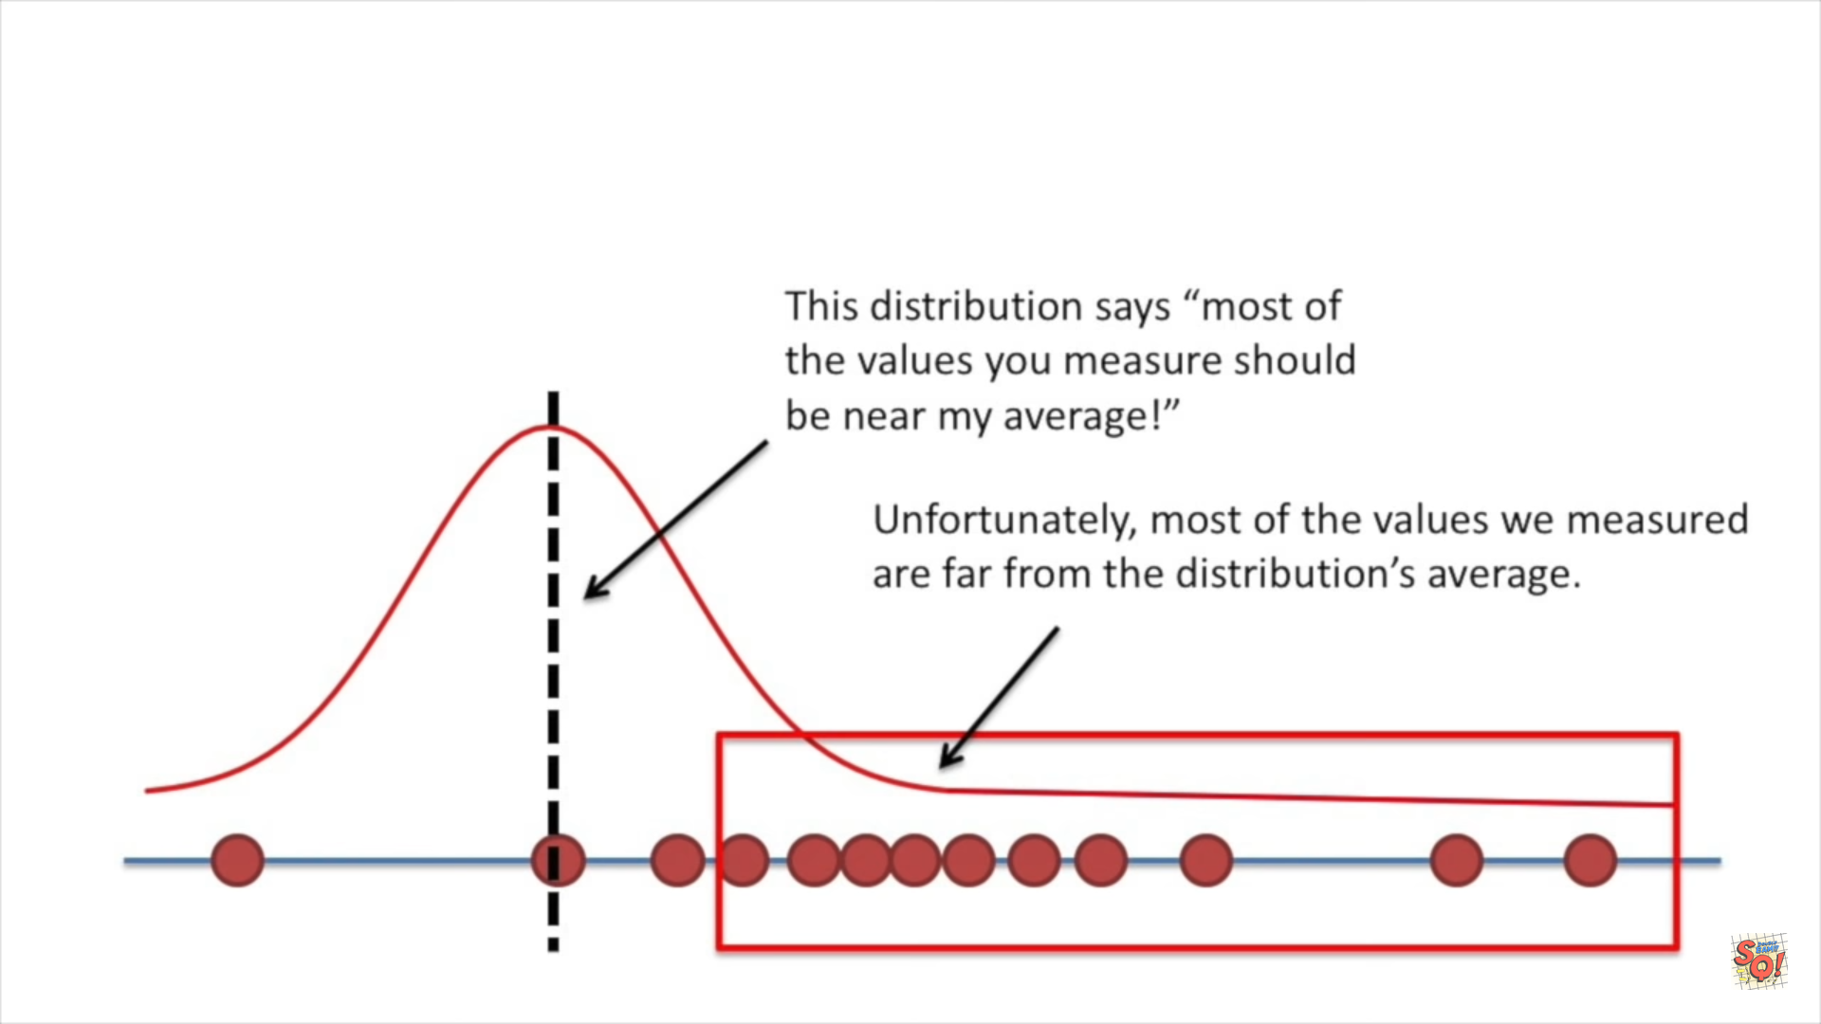

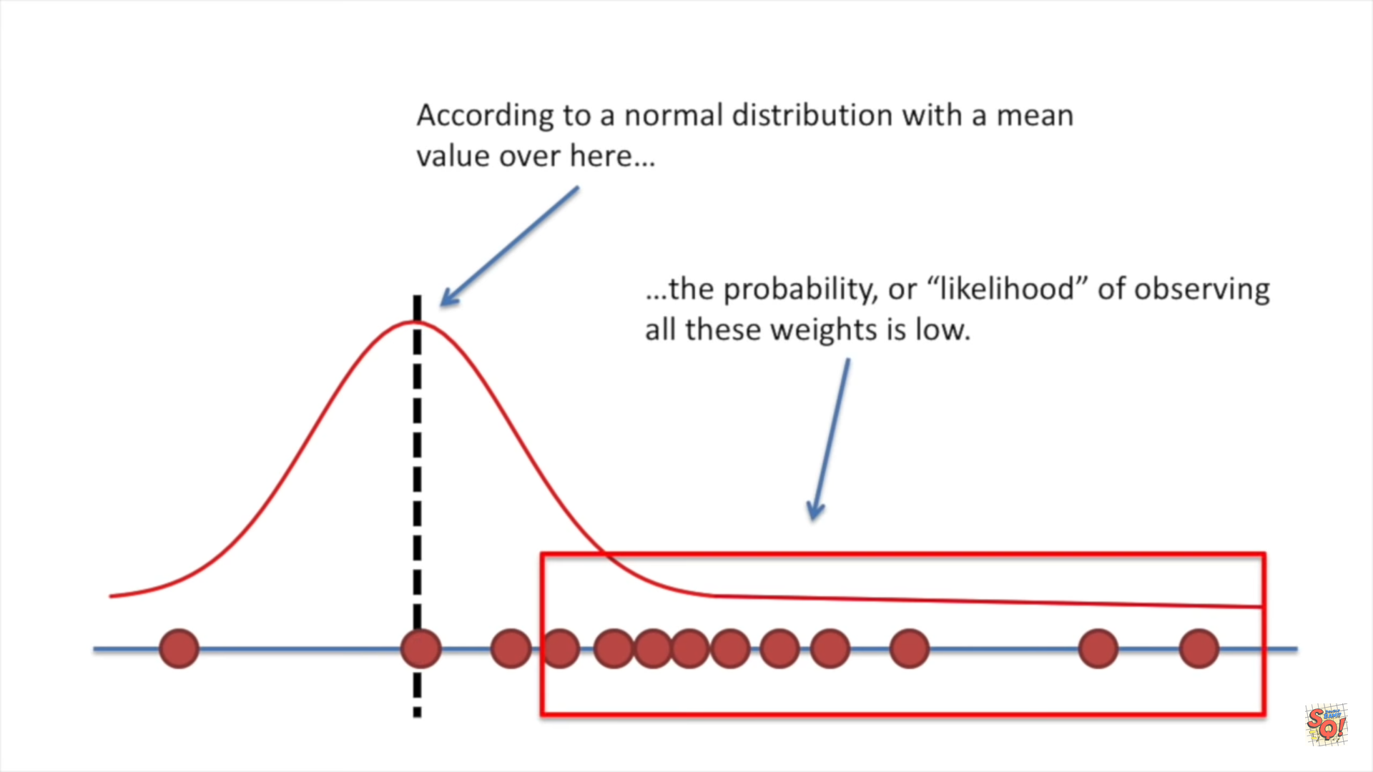



**Case-2**

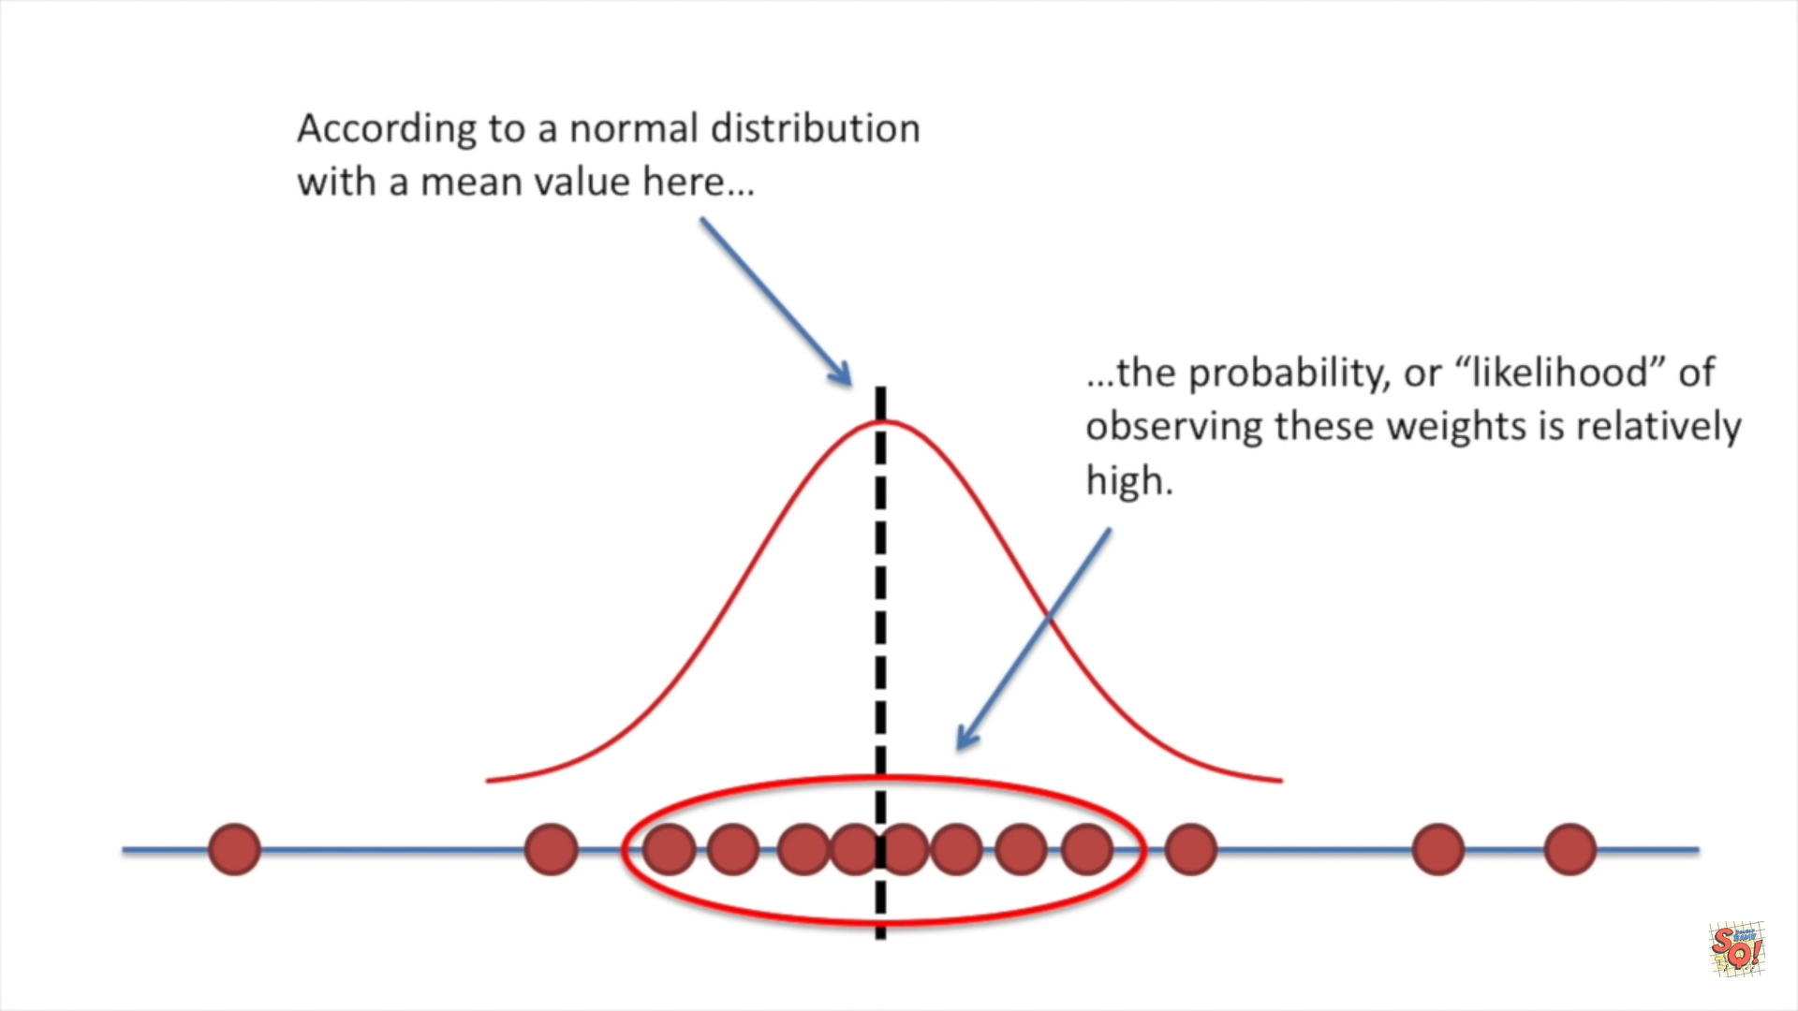



**Case-3**

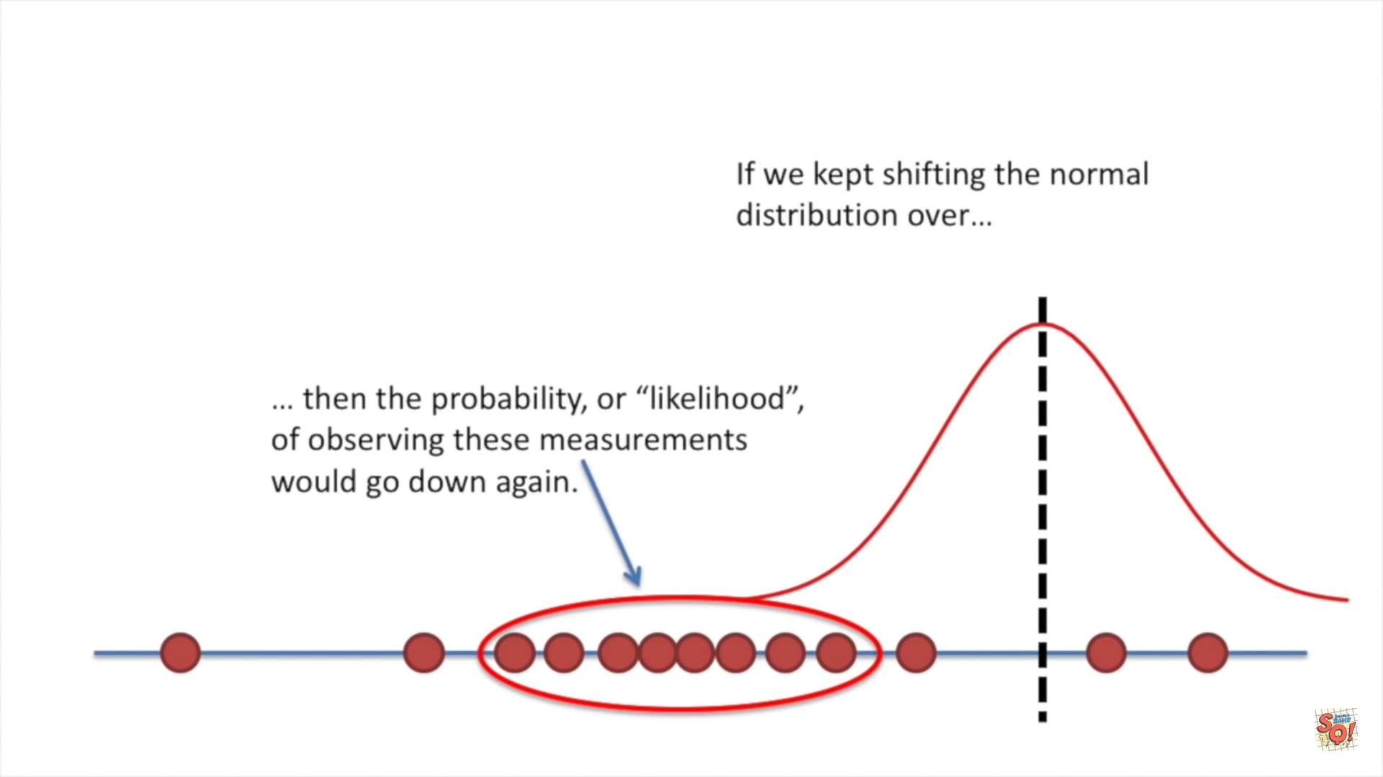



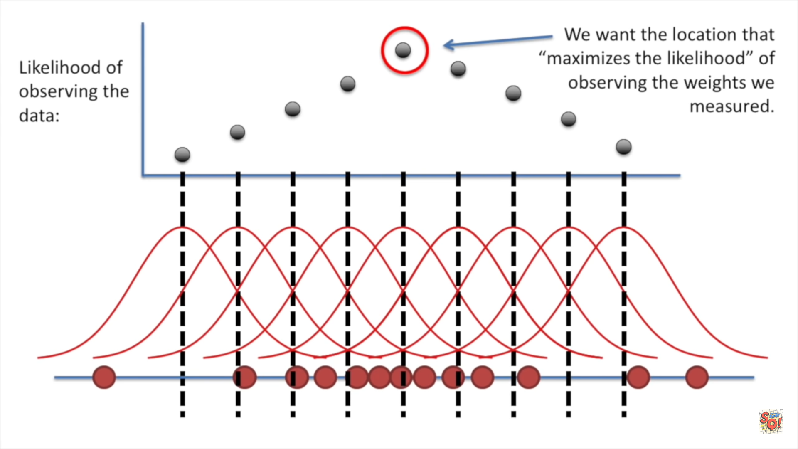

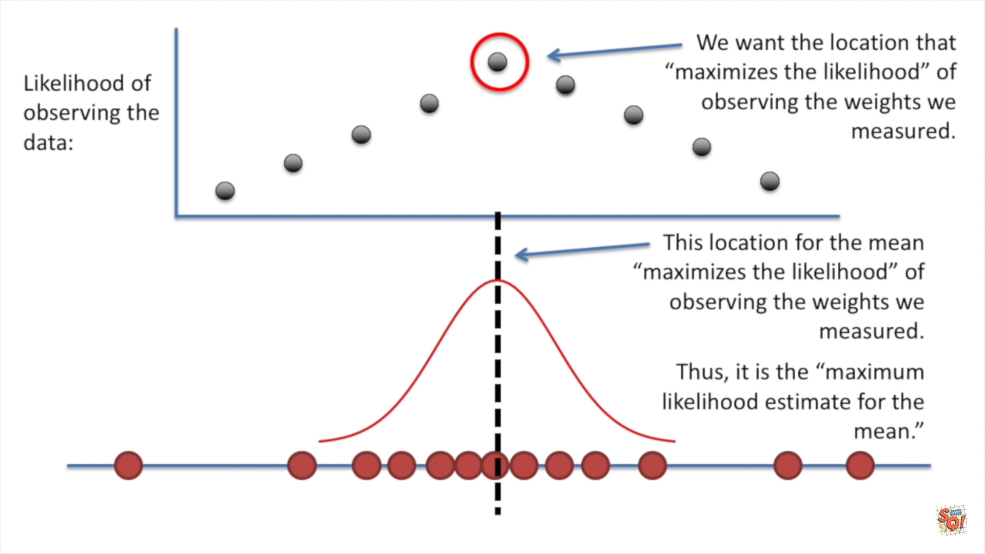

Maximum Likelihood function estimate for the **mean**

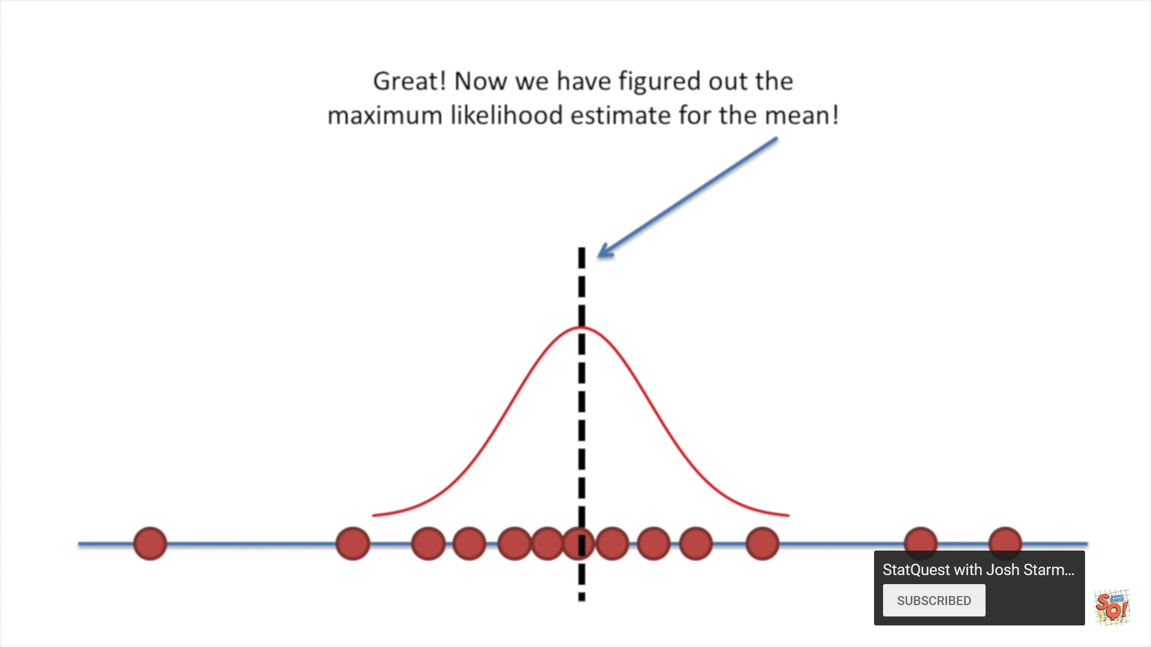



Lets calculate for Maximum Likelihood function estimate for the **standard deviation**

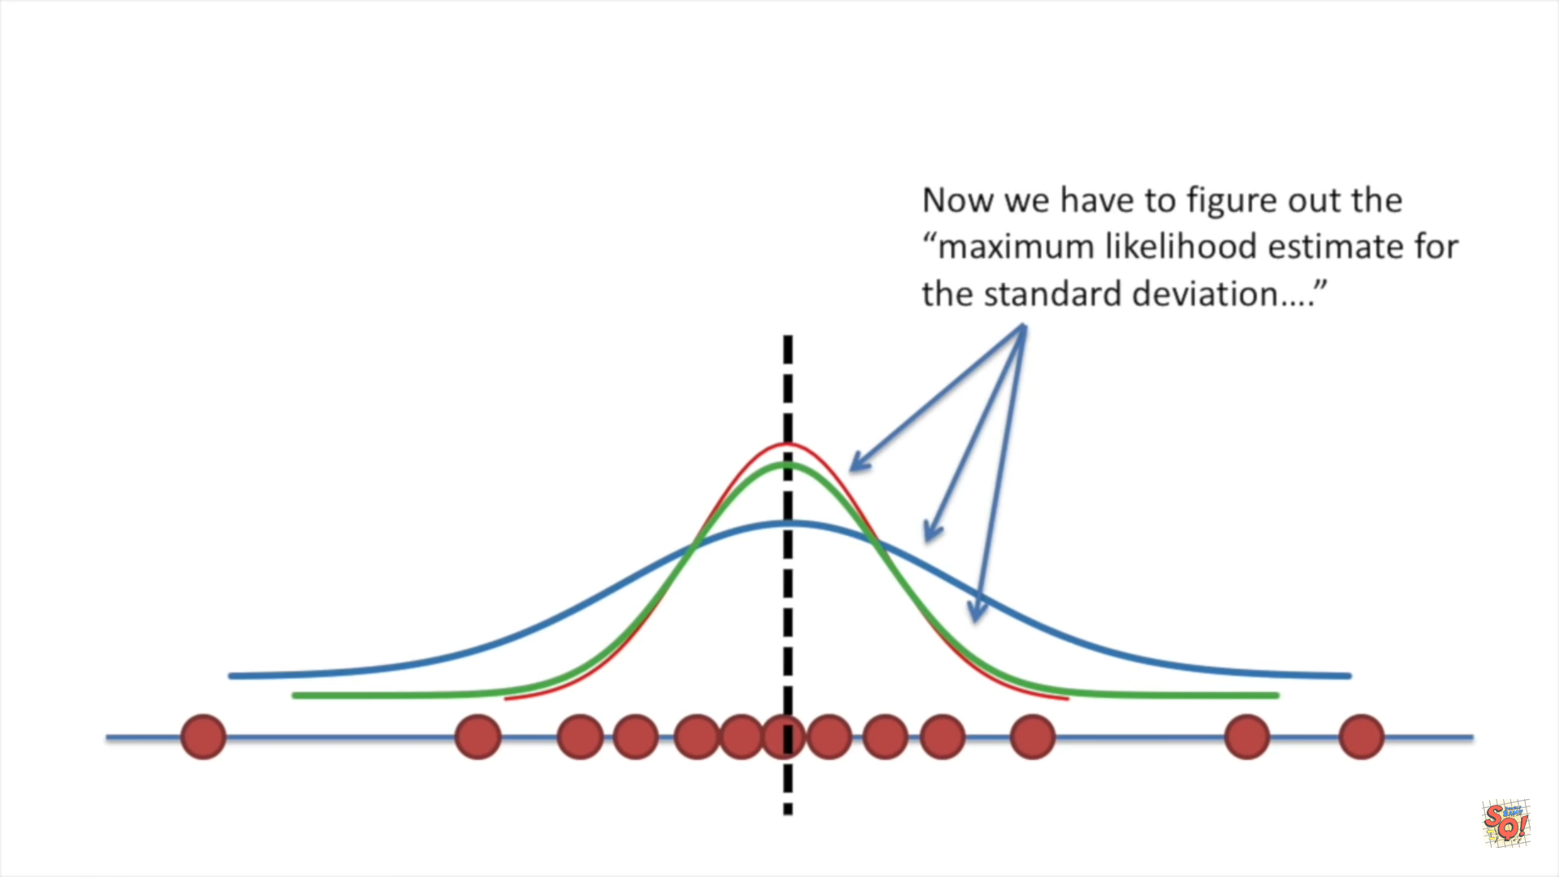



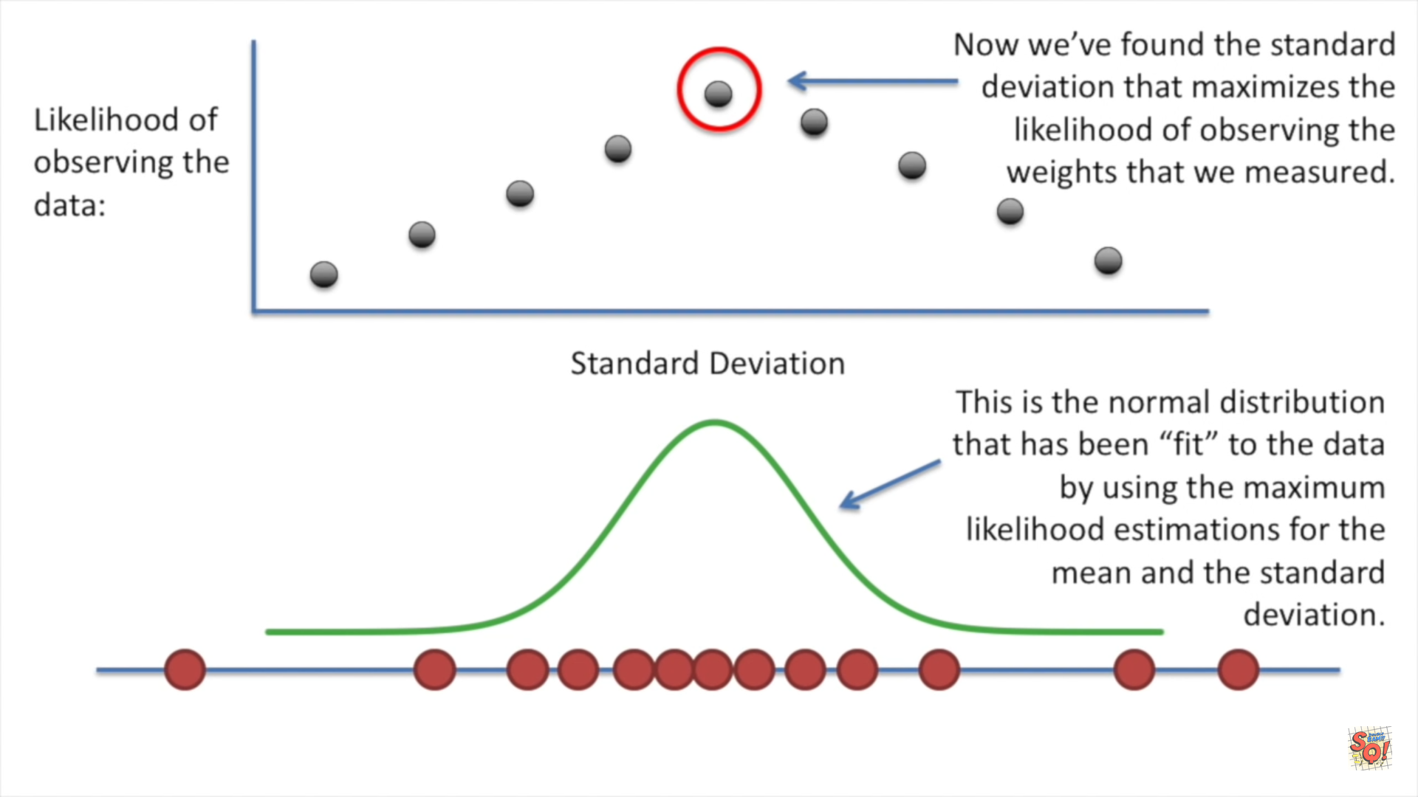

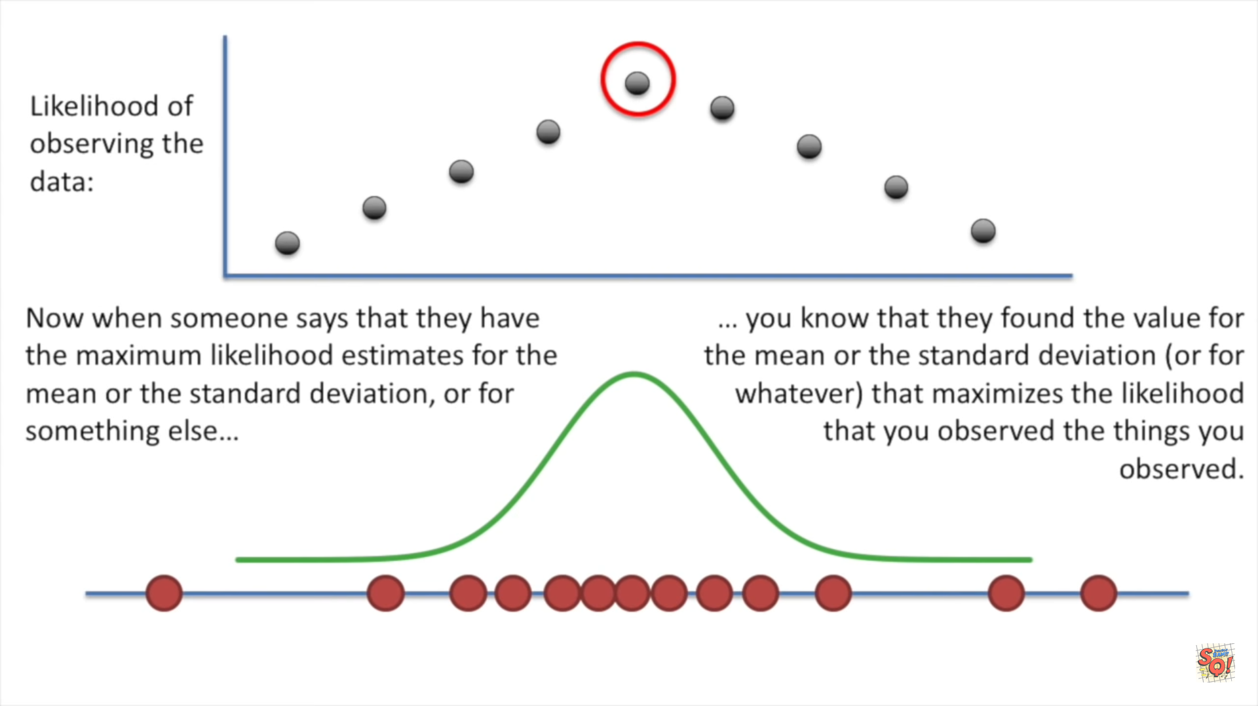

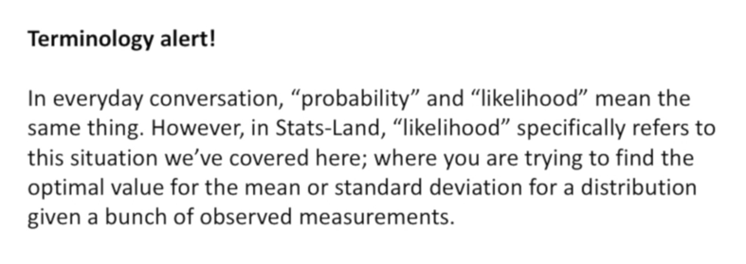

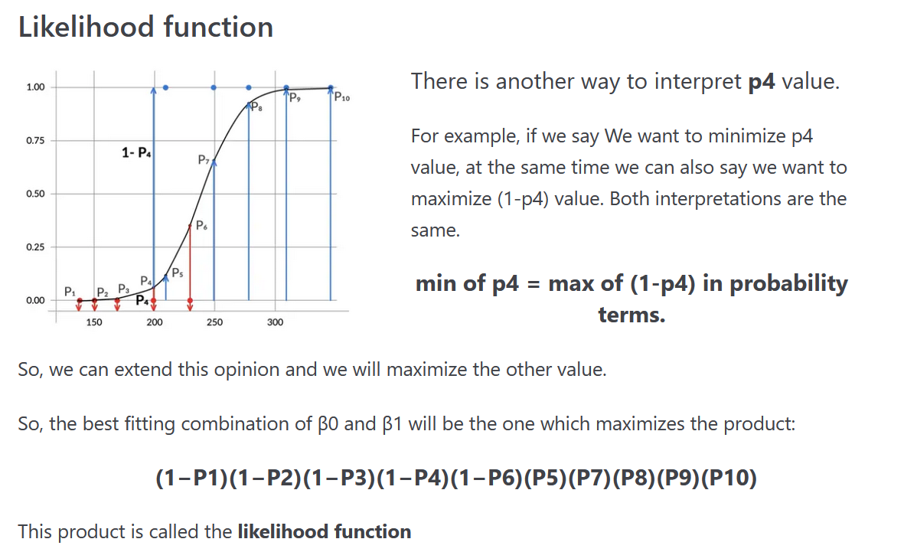



**What is the reason for multiplying all the individual probability??????**All the data-points are independent to each-other.   
Eg: Dog photos Cat photos .



The main idea is we want to find out whether is the image is cat/dog. It doesn’t depend the images within dogs/cats i.e   
(1 image in mobile camera, 1 image in DSLR, 1 image is Labrador, 1 image is kitten etc….)

